

**Online Appointment System for Outpatient Department of Public Hospitals**

**Project Guide: Ciaran Hayden**

**December 2018**

Vishwajeet Khadilkar(x17169984)

Shikhar Srivastava(x18106960)

Lalit Pathak(x18110088)

Ugwuanyi Arinze J.(x18139442)

Table of Contents

[Organisation 5](#_Toc532755317)

[Porter’s 5 Forces (Real Time Board) 5](#_Toc532755318)

[Marketplace in which organisation participate 5](#_Toc532755319)

[Scope and objectives 6](#_Toc532755320)

[Rationale for this Implementing Specific Architecture 6](#_Toc532755321)

[Infrastructure 6](#_Toc532755322)

[Selection of cloud 6](#_Toc532755323)

[Infrastructure 6](#_Toc532755324)

[Product platform selection 6](#_Toc532755325)

[Implementation Approach 7](#_Toc532755326)

[Logical and Physical Design 7](#_Toc532755327)

[Overall Requirement 7](#_Toc532755328)

[Process Flow Diagram 7](#_Toc532755329)

[Process flow Description: 8](#_Toc532755330)

[Data Capture Point 9](#_Toc532755331)

[Entity Relationship Diagram: 10](#_Toc532755332)

[Data Dictionary: 10](#_Toc532755333)

[Table Name: User 10](#_Toc532755334)

[Table Name: Patient 10](#_Toc532755335)

[Table Name: Doctor 11](#_Toc532755336)

[Table Name: Assistant 11](#_Toc532755337)

[Table Name: Department 11](#_Toc532755338)

[Table Name: Room 11](#_Toc532755339)

[Table Name: Medicine 11](#_Toc532755340)

[Table Name: Referral 12](#_Toc532755341)

[Table Name: Appointment 12](#_Toc532755342)

[Table Name: Prescription 12](#_Toc532755343)

[Business & Data Validation rules - Description and Implementation 12](#_Toc532755344)

[BR1 12](#_Toc532755345)

[BR2 13](#_Toc532755346)

[BR3 13](#_Toc532755347)

[BR4 13](#_Toc532755348)

[BR5 13](#_Toc532755349)

[BR6 13](#_Toc532755350)

[BR7 13](#_Toc532755351)

[BR8 14](#_Toc532755352)

[Integration 14](#_Toc532755353)

[Registration Page 14](#_Toc532755354)

[Registration Page Integration 15](#_Toc532755355)

[Appointment Page 16](#_Toc532755356)

[History of Appointment Retrieval 16](#_Toc532755357)

[Integration of Appointment Retrieval Page 17](#_Toc532755358)

[Prescription Retrieval Page 18](#_Toc532755359)

[Integration of Prescription Retrieval Page 18](#_Toc532755360)

[Workflows and Email Alerts 19](#_Toc532755361)

[Reporting and Analytics 20](#_Toc532755362)

[Appointment Handled by Doctor 20](#_Toc532755363)

[Appointment Handled by Department 21](#_Toc532755364)

[Medicine Prescribed 21](#_Toc532755365)

[Appointment Count by Referral Status 21](#_Toc532755366)

[Appointments by Month 21](#_Toc532755367)

[Approach Followed to Build Dataset 21](#_Toc532755368)

[Steps Taken to Build System 21](#_Toc532755369)

[Business Benefits 22](#_Toc532755370)

[Appendix 22](#_Toc532755371)

[1. Registration Web page 22](#_Toc532755372)

[2. Appointment Web page 24](#_Toc532755373)

[3. Appointment Retrieval Web Page 26](#_Toc532755374)

[Web Page: 26](#_Toc532755375)

[Class: 27](#_Toc532755376)

[4. Show Appointment Web Page 28](#_Toc532755377)

[Web Page: 28](#_Toc532755378)

[Class: 29](#_Toc532755379)

[5. Prescription Retrieval Web Page 30](#_Toc532755380)

[Web Page: 30](#_Toc532755381)

[Class: 32](#_Toc532755382)

[6. Show Prescription Web Page 32](#_Toc532755383)

[Web Page: 32](#_Toc532755384)

[Class: 34](#_Toc532755385)

[Bibliography 35](#_Toc532755386)

|  |  |
| --- | --- |
| Team Member | Contribution |
| Vishwajeet Khadilkar(x17169984) | 27% |
| Shikhar Srivastava(x18106960) | 27% |
| Lalit Pathak(x18110088) | 27% |
| Ugwuanyi Arinze J.(x18139442) | 19% |

# Organisation

We are Considering Beaumont Hospital (Beaumont Hospital) which is one of the biggest academic teaching Hospital in Ireland. This Hospital uses Tradition Booking system which includes Mail, Email and Phone call. All the above method required human interaction to analyse the reference letter. This process takes days to reach out to the patient about appointment status through the different communication Medium. The process is a very time-consuming. To overcome this problem we are implementing a cloud-based system, through which it is possible to book an appointment using a Smartphone, web browser with the help of the internet.

# Porter’s 5 Forces (Real Time Board)

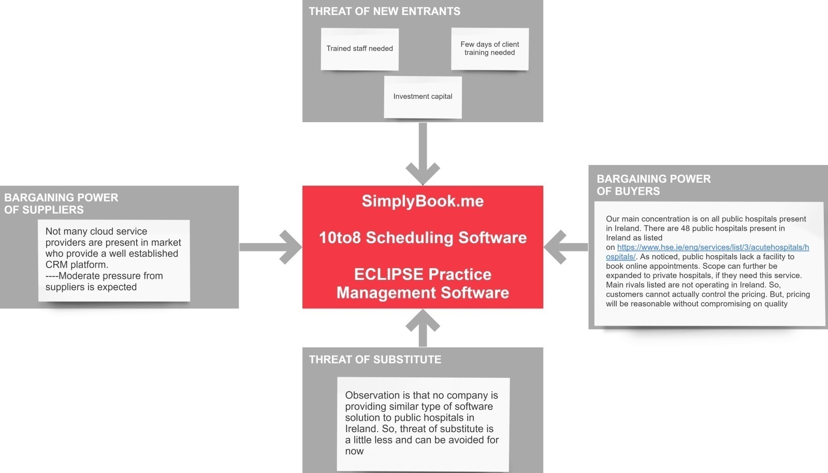

**Target user-group:**

* Public Hospitals and hospitals which have traditional Appointment Booking system – Front-Desk, Doctors and Lab technicians
* General Practitioners
* Patients

# Marketplace in which organisation participate

Healthcare organizations are one of the most important Organisations of the Country and these organizations are directly related to human health. Lots of healthcare system need IT support and management strategies to efficiently provide quality of services and consultation to the Customers.

# Scope and objectives

Nowadays Patients’ involvement increasing in terms of searching best hospital, facilities provided by hospitals and for selecting the Consultant. One of the main reasons for increasing the patients' involvement is due to the use of a medium like internet. There are Different ways for the patient to book the appointment for Consultation. First is to visit the hospital and Book the appointment, sending Electronic Mail or phone call to the hospital. These processes of booking have some problems. It is not possible for the patient who is living outside the city to visit the hospital and book an appointment. Many times it is difficult to identify the mail due to overload of documents in the mailbox. Telephone appointment booking required patient details and the person on the phone call who can help you quickly. There is huge chance of loss of document delivery by hand method of appoint booking .All these traditional methods include human interaction and sometimes because of human error, it may possible to increase the waiting period for the patient to book an appointment so appointment booking does not only depend on the availability of the slot but also depends on schedulers and telephone lines. All these problems may cause frustration and satisfaction to the Patient.

# Rationale for this Implementing Specific Architecture

## Infrastructure

### Selection of cloud

* The­­­­­­ Cloud-Based Online Appointment Booking System beneficial to the management to track and maintain a history of automatically scheduled appointment.
* At the same time it is useful for the patient to select the facilities provided by Hospital.
* Stakeholders can have a holistic view of the processes that take place in the backend.
* It is possible to track the time spent on each appointment request for the management.

### Infrastructure

* Computers, laptop, mobile phones, tablet with internet connectivity
* The organisation Needs to Invest on Salesforce licence.

## Product platform selection

There are different reasons for selection of cloud based Solution for Customer relationship management and also there is option of on-premise software but the problem with these software is they need maintenance and have high cost. Implementation of on-premise software takes time and require training session of the application.

* Flexibility that is, on demand services to scale up and scale down capacity as per requirement.
* Convenient recovery of data which saves lots of investment and time of the organisation.
* All data stored on servers so there is no need to maintain the system as cloud providers automatically roll out software update.
* Its best platform as it requires minimum hardware.
* Centralised documentation as well as control on document.
* Decreased waiting time
* Effective use of the appointment Slots.

# Implementation Approach

Project has been divided in different phases. An image is attached below showing the project plan (Smartsheet.com):

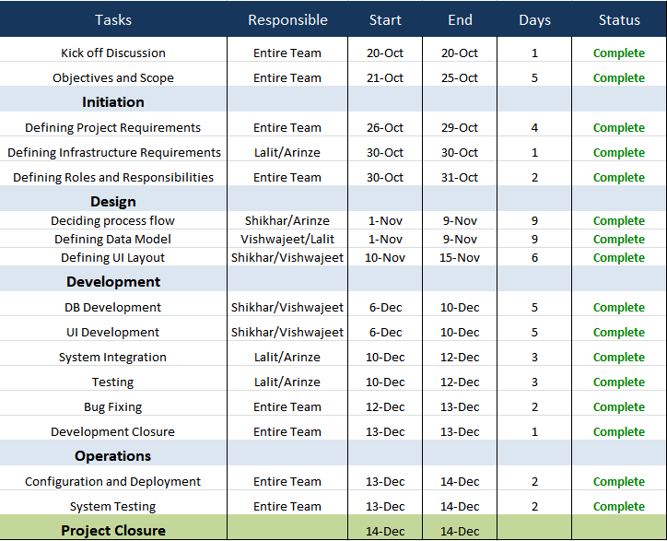

An excel spreadsheet has also been attached below showing a Gantt chart representation of our project plan [3]:



# Logical and Physical Design

## Overall Requirement

* Online Booking System for health care organisation
* Maintain historical data of the appointments .
* Reduce the time required for appointment booking
* Centralise Documentation and ease of access to the user
* Security of the Patient data.

## Process Flow Diagram

Next available appointment scheduled by assistant

Next available appointment scheduled by assistant

Yes

Notification sent to Specialists’ assistant

Referred to Specialist?

GP patient session

Specialist patient session

No

No

Tests assigned?

Patient notified through Email

Yes

Prescription hardcopy given to patient and softcopy uploaded on portal

Patient leave hospital

No

Yes

**Hospital** Valid referral letter

Yes

No

Fill patient details

Details filled automatically

**Hospital** Existing patient?

Notify patient via. Email

Appointment confirmed

Submit Appointment Request Form

Submit Appointment Request Form

Patient uploads referral letter

General Practitioner

Consultant (Specialist)

Patient chooses type of appointment

Doctor selection as mentioned by patient in ARF

Patient enter respective details in appointment request form

Report seen by Doctor

Patient notified through Email

Notification sent to Doctors’ assistant

Report uploaded on portal

Patient take test

Patient visit lab

Notification sent to respective lab assistant

## Process flow Description:

Step 1. Appointment Request Form

* Patient fills his/her personal details like Name, Age, Address, Contact and Email.
* Choice of “Type of Appointment”, whether patient wants to have a session with a General Practitioner or Consultant. List of GPs and Consultant will be made available for patient to choose from, if he/she is having any preference.

1. If Consultant appointment is chosen then patient selects respective Consultant name from the list and uploads a referral letter and submits the form, which is then sent to hospital in the form of Email with referral letter as an attachment.
2. If General Practitioner appointment option is chosen then patient selects respective GP name from the list and submits the form, which is then sent to hospital in the form of Email. In this case, patient does not need to upload a referral letter.

Step 2. Appointment Booking by Hospital

* After receiving the completed appointment request form though Email, hospital validates the details entered by the patient and checks whether the patient is an existing patient or a new patient.
* If patient is an existing patient then his/her details for booking the appointment will be automatically filled in otherwise the hospital will manually fill the details for the appointment.
* Respective GP/Consultant selection is made as mentioned in the application request form by the patient.
* Next available appointment for respective GP/Consultant is booked and appointment confirmation details are the sent to the patient via. Email.

Step 3. GP/Consultant Patient Session

* GP Session: After the session, General Practitioner can either refer the patient to a consultant or if needed, can mark some tests which are required to be taken by the patient. If GP refers the patient to a consultant then in this case, a notification is sent to consultants’ assistant who then schedules the next available appointment of the patient with respective Consultant. If patient is neither referred to a consultant nor has been assigned any tests, then patient leaves hospital with the hardcopy of the prescription and the same uploaded on portal.
* Consultant Session: After the session, a Consultant can either mark some tests which are required to be taken by the patient or the patient leaves hospital with the hardcopy of the prescription and the same uploaded on portal.

Step 4. If Tests are Assigned

* If any test has been assigned to the patient, then a notification is sent to respective lab assistant listing the tests assigned by GP/Consultant.
* Next, the patient goes to lab and takes respective tests.
* Test report is then uploaded to the portal either immediately or at a later date.
* Notification is then sent to the patient and Consultants’ assistant stating that the report is now ready.
* Consultants’ assistant then books the patients’ next available appointment with Consultant.

## Data Capture Point

1) Patient Details from the form submitted by Patient.

2) Appointment Details.

3) Reports of the patient.

## Entity Relationship Diagram:

**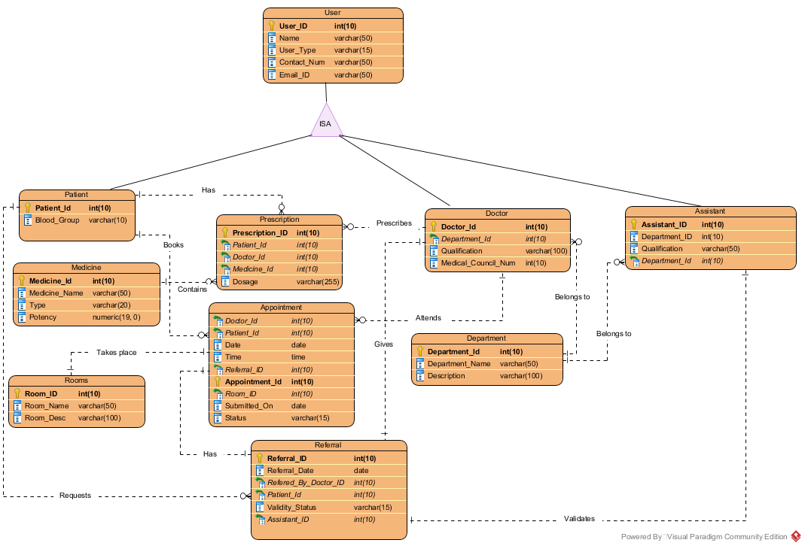**

## Data Dictionary:

### Table Name: User

Description: This table contains common details for all the subtypes of system users

|  |  |  |  |
| --- | --- | --- | --- |
| **Field Name** | **Datatype** | **Length** | **Description** |
| User\_ID | Integer | 10 | Primary Key |
| Name | Varchar | 50 |  |
| Gender | Varchar | 1 |  |
| Email\_ID | Varchar | 50 |  |
| DOB | Date |  |  |
| Contact\_Num | Varchar | 25 |  |
| Type | Varchar | 15 | This column defines type of the user: Patient, Doctor or Assistant |

### Table Name: Patient

Description: This table is a derived table of user table for user type – patient and contains patient specific information which is not applicable to other users

|  |  |  |  |
| --- | --- | --- | --- |
| **Field Name** | **Datatype** | **Length** | **Description** |
| Patient\_ID | Integer | 10 | Foreign key and references to user\_ID of the patient from user table. Acts as a primary key of this table. |
| Blood\_Group | Integer | 10 |  |
| Allergies | Varchar | 100 |  |

### Table Name: Doctor

Description: This table is a derived table of user table for user type – Doctor and contains Doctor specific information which is not applicable to other users

|  |  |  |  |
| --- | --- | --- | --- |
| **Field Name** | **Datatype** | **Length** | **Description** |
| Doctor\_ID | Integer | 10 | Foreign key and references to user\_ID of the doctor from user table. Acts as a primary key of this table. |
| Department\_ID | Integer | 10 | Foreign key from department table |
| Qualification | Varchar | 50 |  |
| Medical\_Council\_Num | int | 10 | Registration number of GP/consultant with medical council |

### Table Name: Assistant

Description: This table is a derived table of user table for user type – Assistant and contains Assistant specific information which is not applicable to other users

|  |  |  |  |
| --- | --- | --- | --- |
| **Field Name** | **Datatype** | **Length** | **Description** |
| Assistant\_ID | Integer | 10 | Foreign key and references to user\_ID of the assistant from user table. Acts as a primary key of this table. |
| Department\_ID | Integer | 10 | Foreign key from department table |
| Qualification | Varchar | 50 |  |

### Table Name: Department

Description: This table contains information abot the departments of the hospital’s outpatient section

|  |  |  |  |
| --- | --- | --- | --- |
| **Field Name** | **Datatype** | **Length** | **Description** |
| Department\_ID | Integer | 10 | Primary key |
| Department\_Name | Varchar | 50 |  |
| Description | Varchar | 100 |  |

### Table Name: Room

Description: This table contains information about the rooms available for appointments, medical tests etc and their location and description

|  |  |  |  |
| --- | --- | --- | --- |
| **Field Name** | **Datatype** | **Length** | **Description** |
| Room\_ID | Integer | 10 | Primary key |
| Room\_Name | Varchar | 50 |  |
| Location | Varchar | 100 |  |
| Description | Varchar | 100 |  |

### Table Name: Medicine

Description: This table contains information about the medicines. These medicines will be visible to doctors while prescribing them to patients.

|  |  |  |  |
| --- | --- | --- | --- |
| **Field Name** | **Datatype** | **Length** | **Description** |
| Medicine\_ID | Integer | 10 | Primary key |
| Medicine\_Name | Varchar | 50 |  |
| Potency | Varchar | 100 |  |
| Type | Varchar | 100 | Type of medicine: eg. tablet, syrup etc |

### Table Name: Referral

Description: This table captures referral details for patient’s appointment and its validity

|  |  |  |  |
| --- | --- | --- | --- |
| **Field Name** | **Datatype** | **Length** | **Description** |
| Referral\_ID | Integer | 10 | Primary key |
| Referral\_Date | date |  |  |
| Refered\_By\_Doctor\_ID | int | 10 | Foreign key and references to user\_ID of the doctor from user table. |
| Patient\_Id | int | 10 | Foreign key and references to user\_ID of the patient from user table. |
| Validity\_Status | varchar | 15 | After verification of the referral, assistant will mark this as accept or reject |
| Assistant\_ID | int | 10 | Foreign key and references to user\_ID of the assistant from user table. |

### Table Name: Appointment

Description: This table stores information about the appointment of patient with doctor

|  |  |  |  |
| --- | --- | --- | --- |
| **Field Name** | **Datatype** | **Length** | **Description** |
| Doctor\_Id | Int | 10 | Foreign key and references to user\_ID of the doctor from user table. |
| Patient\_Id | Int | 10 | Foreign key and references to user\_ID of the patient from user table. |
| Date | Date |  |  |
| Time | Time | 7 |  |
| Referral\_ID | Int | 10 | Foreign key and references to Referral\_ID of the from Referral table. |
| Appointment\_Id | Int | 10 | Primary key |
| Room\_ID | Int | 10 | Foreign key and references to Room\_ID of the from Room table. |
| Submitted\_On | Date |  |  |
| Status | Varchar | 15 | Status : Approved/Rejected/OnHOld |

### Table Name: Prescription

Description: This table contains medicines prescribed to the patient by doctor

|  |  |  |  |
| --- | --- | --- | --- |
| **Field Name** | **Datatype** | **Length** | **Description** |
| Prescription\_ID | Int | 10 | Primary key |
| Patient\_Id | Int | 10 | Foreign key and references to user\_ID of the patient from user table. |
| Doctor\_Id | Int | 10 | Foreign key and references to user\_ID of the doctor from user table. |
| Medicine\_Id | Int | 10 | Foreign key and references to Medicine\_ID of the from Medicine table. |
| Dosage | Varchar | 255 | Frequency and quantity of medicine to be consumed |
| Date | Varchar | 50 | Stores Date when Prescription was uploaded |

# Business & Data Validation rules - Description and Implementation

## BR1

|  |  |
| --- | --- |
| **Name:** | A GP and Consultant must have a Medical council number |
| **Identifier:** | BR1 |
| **Description:** | All the general practitioners and consultants (Specialists) must have a valid registration number provided by medical council. |
| **Implementation** | A field named: Medical\_Council\_Num is included in table #Doctor. This field cannot be left null. |

## BR2

|  |  |
| --- | --- |
| **Name:** | A medical test can be performed only when a general practitioner or consultant recommends it |
| **Identifier:** | BR2 |
| **Description:** | Medical tests can only be performed if a GP or consultant suggest them to the patient |
| **Implementation** | A field named: Doctor\_ID is included in table #Report. This field cannot be left null. |

## BR3

|  |  |
| --- | --- |
| **Name:** | An appointment with consultant(specialist) will only be confirmed upon submission of valid referral letter from General Practitioner |
| **Identifier:** | BR3 |
| **Description:** | A patient can request appointment with consultant only if it is accompanied by a valid referral letter from a GP |
| **Implementation** | A table named #Referral is maintained to store referral related details. Primary key from this table named: Referral\_ID is included in table #Appointment as a foreign key. This field cannot be left null. |

## BR4

|  |  |
| --- | --- |
| **Name:** | An appointment can have only predefined status types |
| **Identifier:** | BR4 |
| **Description:** | The possible values of an appointment’s status are Approved, Rejected, On Hold, To Be Processed, Processed |
| **Implementation** | A field named: Status is included in table #Apointment. Value for this field can only be selected from predefined set of values using a drop-down list |

## BR5

|  |  |
| --- | --- |
| **Name:** | The referral letter be in certain file type and size |
| **Identifier:** | BR5 |
| **Description:** | The referral letter must be uploaded in pdf or doc/docx format with size less than 1MB only |
| **Implementation** | A validation script will be used to perform this check on patient’s appointment submission form |

## BR6

|  |  |
| --- | --- |
| **Name:** | An appointment request must be processed within SLA |
| **Identifier:** | BR6 |
| **Description:** | An appointment request must be processed within one business day. |
| **Implementation** | A field named: Submitted\_On is included in table #Appointment. A reminder will be triggered if a request is not processed within SLA. The value of column status must then be changed from to be processed to either approved/rejected/kept on hold or processed. |

## BR7

|  |  |
| --- | --- |
| **Name:** | Patient’s health history must be documented and made available to GP/Consultants |
| **Identifier:** | BR7 |
| **Description:** | All the current and historic reports and prescriptions of the patient must be made available to GP/Consultants for ease of understanding of patient’s health history |
| **Implementation** | A table named #Report is maintained for this purpose. For each test taken and prescription prescribed, an entry will be made in this table for future references. |

## BR8

|  |  |
| --- | --- |
| **Name:** | A report must contain details of the technician that performs and documents the medical test |
| **Identifier:** | BR8 |
| **Description:** | Medical tests can only be performed if a GP or consultant suggests them to the patient. It is lab technician’s responsibility to verify and perform the necessary tests and upload the results in the system for further use. |
| **Implementation** | A field named: Assistant\_ID is included in table #Report. This field cannot be left null. |

# Integration

## Registration Page

For patients to access this online appointment booking service, we have built a registration page where new patients can go and register themselves. After registering, patient can request for an appointment through an online appointment request form. We have also made our registration page public for which the link is -- <https://ictprojecthospital-developer-edition.eu16.force.com/NCIonlineopd/>. Image of registration web page is shown as below:

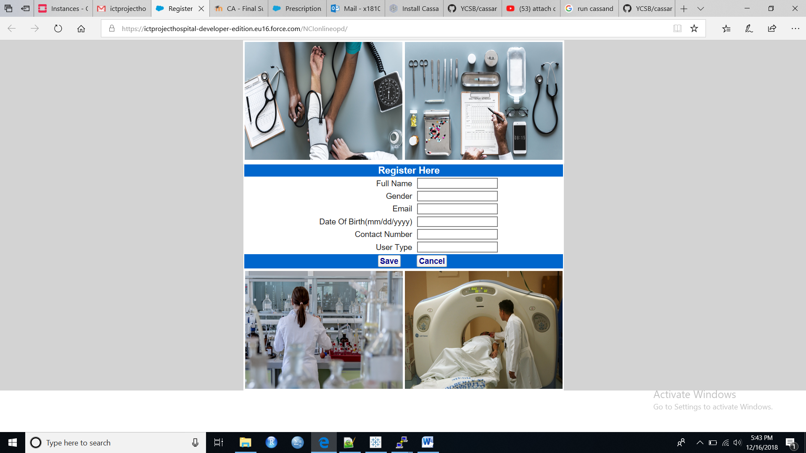

Patient will not be able to create a new record if he/she has entered an invalid value in any of the fields on the registration web page. Please refer below image where we have checked for one of such validation on email ID:

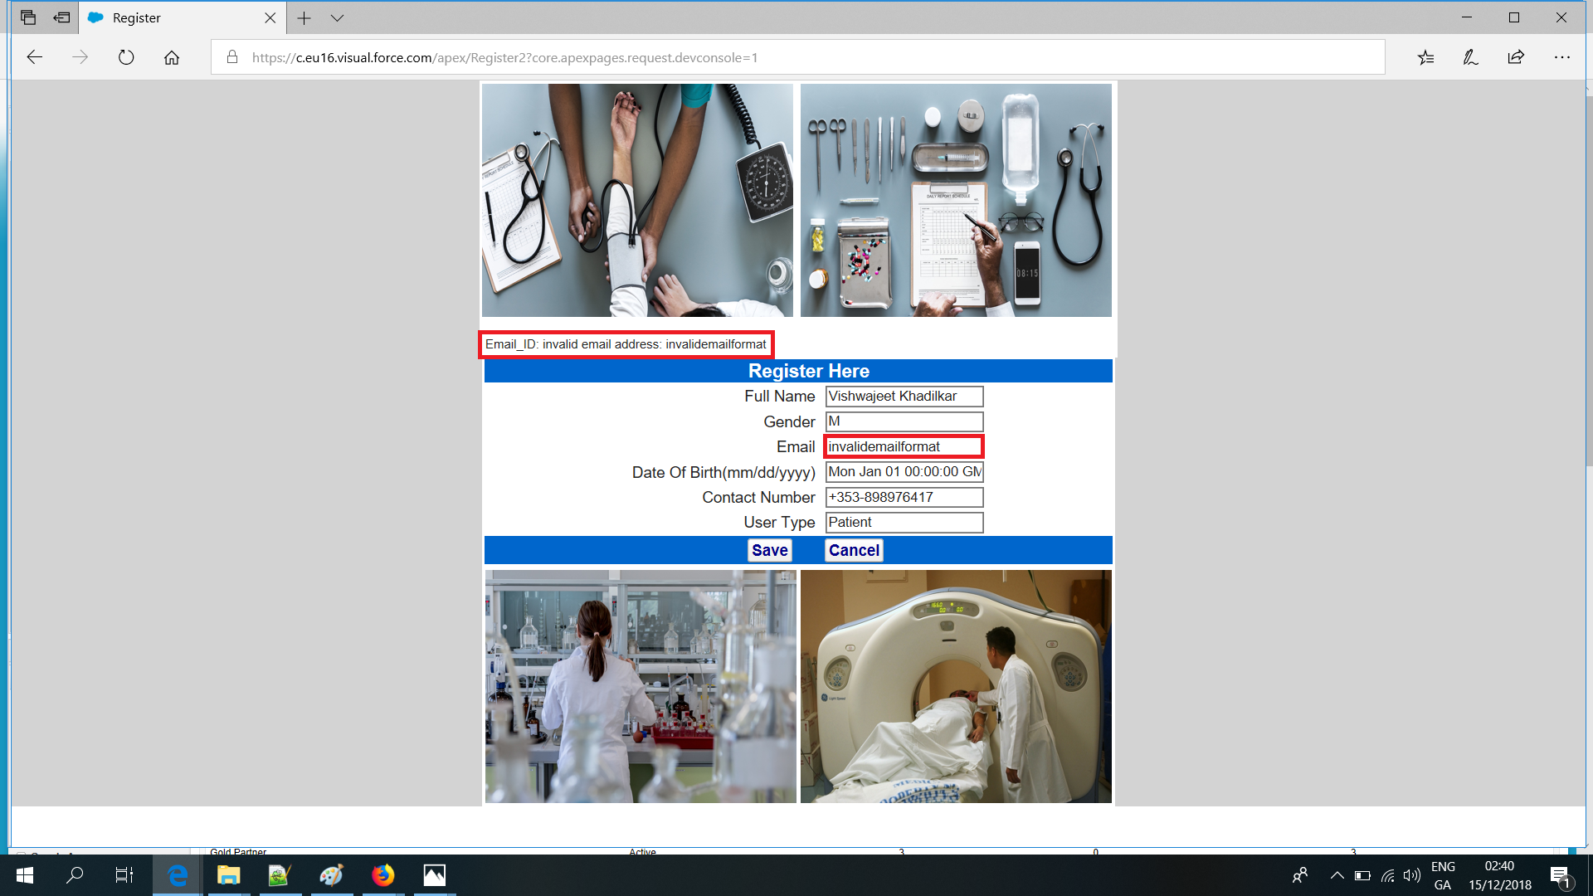

We have also checked whether a record is inserted if patient has entered everything in a correctly. Image attached below:

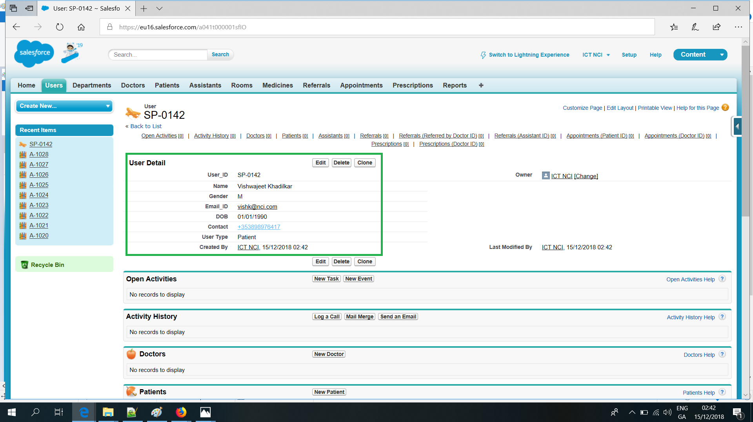

### Registration Page Integration

#### Fields present on the registration web page are mapped to the fields in User custom object as follows:

|  |  |
| --- | --- |
| **Registration Web Page** | **User Custom Object** |
| Full name | User\_\_c.Name\_\_c |
| Gender | User\_\_c.Gender\_\_c |
| Email | User\_\_c.Email\_ID\_\_c |
| Date Of Birth(mm/dd/yyyy) | User\_\_c.DOB\_\_c |
| Contact Number | User\_\_c.Contact\_\_c |
| User Type | User\_\_c.User\_Type\_\_c |

#### 

#### Code for the registration web page is present in the appendix of this document.

## Appointment Page

#### This page will be used to book an appointment if a patient wishes to. Appointment booking page will look like:

#### C:\Users\MY\Downloads\Book_Appointment.png

#### Code written to build this web page is present in the appendix.

## History of Appointment Retrieval

#### Our project also comes with a web page through which a patient will be able to retrieve his/her upcoming appointment details and will also be able to see his/her entire appointment history with the hospital. This is how our appointment retrieval page looks like:

#### C:\Users\MY\Downloads\Appointment_1.png

### Integration of Appointment Retrieval Page

#### When a patient ID is entered and “Retrieve Appointment” button is clicked, “AppointmentLookup” class is called which further calls the web page “showAppointment” which shows appointment details for the patient ID entered. Details of appointment are shown on screen because “showAppointment” page invokes another class “RetrieveAppointment”. Fields which are shown on screen to user are pulled from “Appointment”, “User”, “Department” and “Room” custom objects. The relationship between these tables is established using SOQL syntax which is equivalent to joins in SQL. All codes for both classes and web pages are present in the appendix. List of fields pulled are:

#### SLx.Patient\_ID\_\_c

#### SLx.Patient\_ID\_\_r.Name\_\_c

#### SLx.Date\_\_c

#### SLx.Time\_\_c

#### SLx.Department\_ID\_\_r.Department\_Name\_\_c

#### SLx.Doctor\_ID\_\_r.Name\_\_c

#### SLx.Room\_ID\_\_r.Location\_\_c

#### SLx.Room\_ID\_\_r.Room\_Name\_\_c

#### SLx.Status\_\_c

#### This is how the appointment details retrieval page looks like:

#### C:\Users\MY\Downloads\Appointment_2.png

## Prescription Retrieval Page

#### A patient can see his/her prescription details from this page. History of all prescriptions of a particular patient will be visible on this page. Image of web page:

#### C:\Users\MY\Downloads\Prescription_1.png

### Integration of Prescription Retrieval Page

#### When a patient ID is entered and “Retrieve Prescription” button is clicked, “PrescriptionLookup” class is called which further calls the web page “showPrescription” which shows prescription details for the patient ID entered. Details of prescription are shown on screen because “showPrescription” page invokes another class “RetrievePrescription”. Fields which are shown on screen to user are pulled from “Prescription”, “User” and “Medicine” custom objects. The relationship between these tables is established using SOQL syntax which is equivalent to joins in SQL. All codes for both classes and web pages are present in the appendix. List of fields pulled are:

#### SLx.Patient\_ID\_\_c

#### SLx.Patient\_ID\_\_r.Name\_\_c

#### SLx.Doctor\_ID\_\_r.Name\_\_c

#### SLx.Medicine\_ID\_\_r.Medicine\_Name\_\_c

#### SLx.Medicine\_ID\_\_r.Potency\_\_c

#### SLx.Medicine\_ID\_\_r.Type\_\_c

#### SLx.Dosage\_\_c

#### SLx.Date\_\_c

# Workflows and Email Alerts

Project is also capable of sending email alerts if any patient is registering for the first time or if an appointment has been confirmed and booked for a particular patient. An email template was created for sending these automated emails to patients. Images of workflows and email templates created are as follows:

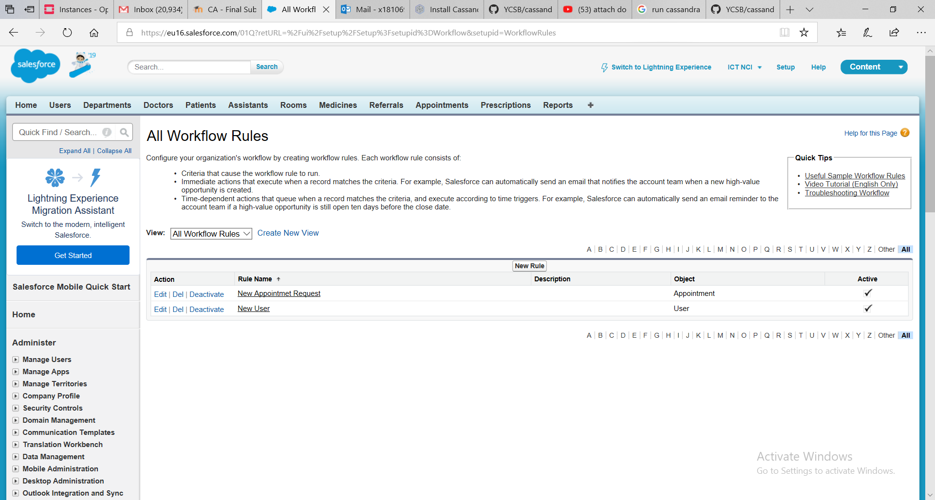

#### Last 2 email templates present in the image below are the templates which we created for automated emails to patients

#### 

# Reporting and Analytics

We have built a dashboard which is having four reports in it. Image of the dashboard is as attached as below:

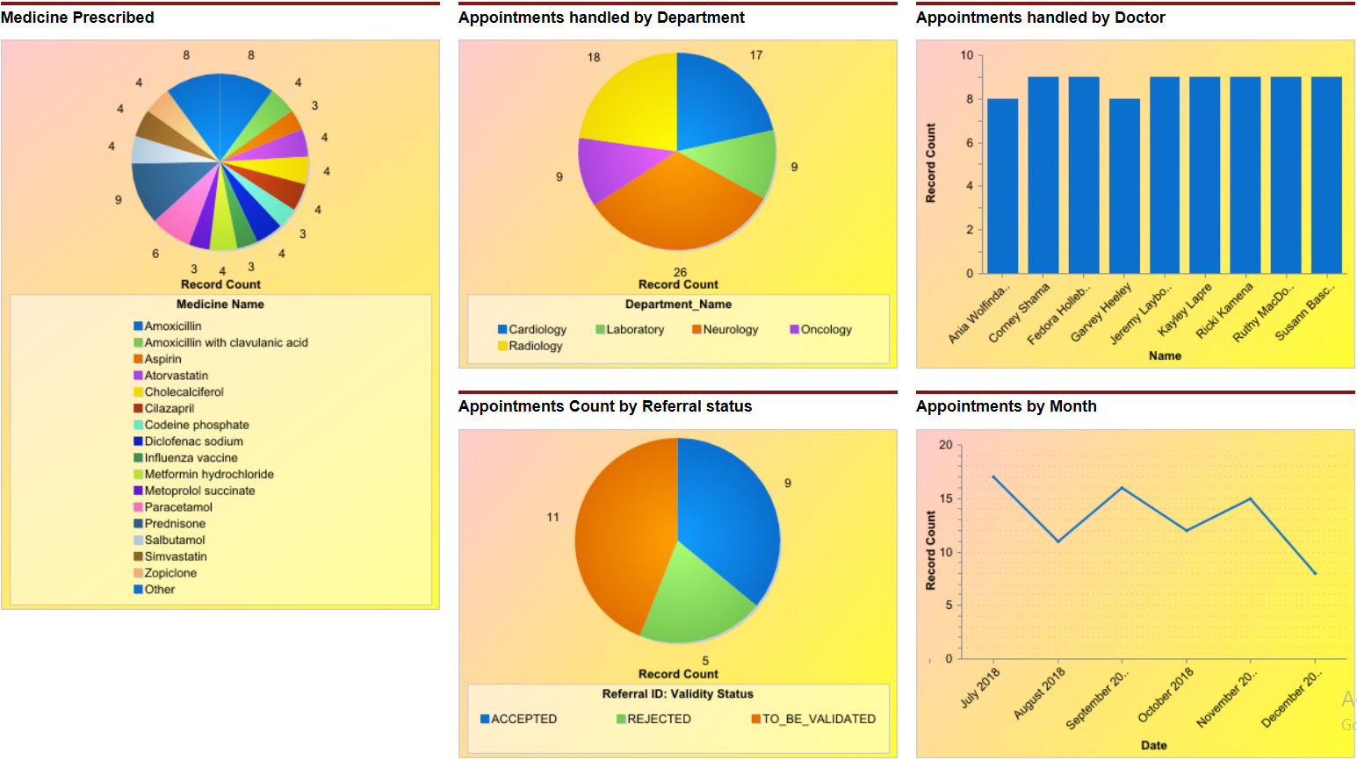

Following reports are created to deliver insights of our project:

## Appointment Handled by Doctor

#### This report shows the number of appointments a doctor has handled till date. By this report, hospital management will be able to monitor which doctor is handling a large number of reports and is overloaded.

## Appointment Handled by Department

#### Number of appointments is shown in this graph which is grouped by department. Insight, like which department is getting many appointment requests can be seen using this chart. Hospital management can act accordingly to optimise things in department with high appointment requests which can further streamline processes.

## Medicine Prescribed

By looking at the number of times a medicine has been prescribed, hospital can get insights like in a particular season, which medicines were prescribed a lot which can further be shared by the hospital with pharmacies and medical representatives to confirm availability in future.

## Appointment Count by Referral Status

Number of appointment count by referral status will help the hospital to see appointment count which required a referral letter and which did not, categorized by four categories – ‘REJECTED’, ‘TO\_BE\_VALIDATED’, ‘ACCEPTED’, ‘REFERRAL\_NOT\_REQUIRED’.

## Appointments by Month

This report will help the hospital to monitor number of appointments it has handled on a monthly basis and will help to track months or periods during which there is a rush and many people look for an appointment at the hospital.

# Approach Followed to Build Dataset

Mock data is prepared for our project from Mockaroo which is based on 10 custom objects built in salesforce. Fields of all 10 tables are explained in detail under entity relationship heading of this document. In tables defined in our entity relationship diagram, we have created auto generated unique IDs in salesforce. Data present in other fields like Allergy (Wikipedia), Medicine Names (Pharmac.govt.nz), Department (Medicalcouncil.ie), Doctor Qualification (Medicalcouncil.ie) and Medical Council Number (Medicalcouncil.ie) was searched over the internet and real values were inserted in this system. Fields for which Real like values were inserted in tables are as follows:

1. Allergens – List of common allergens are picked up from Wikipedia and then inserted in this field which is present in ‘Patient’ table.
2. Medicine Name – Different commonly used medicines are taken from pharmac.govt.nz and are used in ‘Medicine’ table under medicine name field.
3. Doctor Qualification – Few values are taken from medicalcouncil.ie which are used in field qualification in table ‘Doctor’
4. Medical Council Number – Medical council number is also taken from the same web site form where doctor qualification is taken. Here, we noticed that for every doctor (if you search doctor by any forename) the medical council number was of six digits. We have built our data for this field accordingly.

Reports were kept in mind while creating the tables and inserting data.

# Steps Taken to Build System

Steps followed to build this system are as follows:

**Step 1.** All custom objects required for our system were built and represented as tabs. Default objects present in salesforce were hidden. Relationship between objects was defined while creating these custom objects.

**Step 2.** Data for these custom objects was prepared on mockaroo. Sample of real life data was used for few fields like medicine name, allergy etc.

**Step 3.** Third step was to build the reports and put them in a single dashboard. Reports like ‘Appointment Count by Doctor’, ‘Appointment Count by Department’, ‘Number of Times a Medicine has been Prescribed’ and ‘Number of Appointments by Referral Status’

**Step 4.** Registration web page was built for patients to register themselves if they are booking an appointment for the first time. ID generated from this page will further be used to apply for an appointment through appointment request for web page.

**Step 5.** Next, the appointment request form web page was created. This web page will be used by patients to apply for an appointment.

**Step 6.** Registration Web Page was made public by assigning it a domain. Workflows for email alerts were also created.

# Business Benefits

Beaumont hospital currently lacks the capability of booking an appointment online and patient has to visit the hospital in person to book it. If this system of booking an appointment online is used by the hospital, process of booking an appointment can be streamlined with no one standing in queues. It will help the hospital management to keep a record of all the appointments and patients treated by the hospital which can be tracked and monitored by the management through reports which we have built. Moreover, the process of booking an offline appointment and maintaining piles of forms involves a lot of administrative tasks to be performed by the hospital which in turn involves extra expenditure for these tasks. By implementing this salesforce solution, Beaumont hospital can get rid of most of the administrative tasks and can save a lot of money.

# Appendix

## Registration Web page

<apex:page title="Register" Standardcontroller="User\_\_c"

showHeader="false" standardStylesheets="true">

<apex:define name="body">

<apex:form style="background-color:lightgrey;">

<!-- Section to display the error mesages -->

<table align="center" border="0" bgcolor="#FFFFFF">

<tr>

<td><apex:image id="theImage1" value="{!$Resource.bpcheck}" alt="bpcheck" width="300" height="225"/></td>

<td><apex:image id="theImage2" value="{!$Resource.doctorchecklist}" alt="doctorchecklist" width="300" height="225"/></td>

</tr>

<tr><td colspan="2" width="605"> <apex:messages id="error" styleClass="errorMsg"

layout="table" style="margin-top:1em;"/></td></tr>

</table>

<table align="center" border="0" width="610" class="main"

style="font-size:15px;color:Blue;" bgcolor="#FFFFFF">

<tr Align="Center" bgcolor="#0066CC"><td colspan="3" style="font-size:18px;color:White;">&nbsp;&nbsp;&nbsp;&nbsp;<b>Register Here</b></td></tr>

<tr><td align="right">Full Name</td><td></td><td><apex:inputText id="NameInput" value="{!User\_\_c.Name\_\_c}"/></td></tr>

<tr><td align="right">Gender</td><td></td><td><apex:inputText id="GenderInput" value="{!User\_\_c.Gender\_\_c}"/></td></tr>

<tr><td align="right">Email</td><td></td><td><apex:inputText id="EmailInput" value="{!User\_\_c.Email\_ID\_\_c}"/></td></tr>

<tr><td align="right">Date Of Birth(mm/dd/yyyy)</td><td></td><td><apex:inputText id="DOBInput" value="{!User\_\_c.DOB\_\_c}"/></td></tr>

<tr><td align="right">Contact Number</td><td></td><td><apex:inputText id="ContactInput" value="{!User\_\_c.Contact\_\_c}"/></td></tr>

<tr><td align="right">User Type</td><td></td><td><apex:inputText id="UserTypeInput" value="{!User\_\_c.User\_Type\_\_c}" /></td></tr>

<tr bgcolor="#0066CC"><td align="center" colspan="3">&nbsp;&nbsp;&nbsp;&nbsp;&nbsp;&nbsp;&nbsp;&nbsp;<apex:commandButton value="Save" action="{!save}" style="font-weight:bold;font-size:15px;color:darkblue;"/>&nbsp;&nbsp;&nbsp;&nbsp;&nbsp;&nbsp;&nbsp;<apex:commandButton value="Cancel" onclick="top.history.go(-1);return false;" style="font-weight:bold;font-size:15px;color:darkblue;"/></td></tr>

</table>

<table align="center" border="0" bgcolor="#FFFFFF">

<tr>

<td><apex:image id="theImage3" value="{!$Resource.laboratory}" alt="laboratory" width="300" height="225"/></td>

<td><apex:image id="theImage4" value="{!$Resource.mri}" alt="mri" width="300" height="225"/></td>

</tr>

</table>

</apex:form>

</apex:define>

</apex:page>

## Appointment Web page

<apex:page title="Register" Standardcontroller="Appointment\_\_c"

showHeader="false" standardStylesheets="true">

<apex:define name="body">

<apex:form style="background-color:lightgrey;">

<!-- Section to display the error mesages -->

<table align="center" border="0" bgcolor="#FFFFFF">

<tr>

<td><apex:image id="bap1" value="{!$Resource.bap1}" alt="bap1" width="300" height="225"/></td>

<td><apex:image id="bap2" value="{!$Resource.bap2}" alt="bap2" width="300" height="225"/></td>

</tr>

<tr><td colspan="2" width="605"> <apex:messages id="error" styleClass="errorMsg"

layout="table" style="margin-top:1em;"/></td></tr>

</table>

<table align="center" border="0" width="610" class="main"

style="font-size:15px;color:Blue;" bgcolor="#FFFFFF">

<tr Align="Center" bgcolor="#0066CC"><td colspan="3" style="font-size:18px;color:White;">&nbsp;&nbsp;&nbsp;&nbsp;<b>Book Appointment Here</b></td></tr>

<tr>

<td align="right">Patient ID</td><td></td>

<td><apex:inputtext value="{!Appointment\_\_c.Patient\_ID\_\_c}" id="PID"/></td>

</tr>

<tr>

<td align="right">Department</td><td></td>

<td><apex:inputtext value="{!Appointment\_\_c.Department\_ID\_\_c}" id="DID"/></td>

</tr>

<tr>

<td align="right">Type of Appointment</td><td></td>

<td><apex:inputtext value="{!Appointment\_\_c.Appointment\_Type\_\_c}" id="TOA"/></td>

</tr>

<tr>

<td align="right">Date [mm/dd/yyyy]</td><td></td>

<td><apex:inputtext value="{!Appointment\_\_c.Date\_\_c}" id="DT"/></td>

</tr>

<tr>

<td align="right" width="300">Time [hh:mm]</td><td></td>

<td><apex:inputtext value="{!Appointment\_\_c.Time\_\_c}" id="TM"/></td>

</tr>

<tr>

<td align="right">Upload Referral</td><td></td>

<td>

<apex:inputFile value="File" fileName="F1" styleclass="form-control"/>

</td>

</tr>

<tr bgcolor="#0066CC"><td align="center" colspan="3">&nbsp;&nbsp;&nbsp;&nbsp;&nbsp;&nbsp;&nbsp;&nbsp;<apex:commandButton value="Save" action="{!save}" style="font-weight:bold;font-size:15px;color:darkblue;"/>&nbsp;&nbsp;&nbsp;&nbsp;&nbsp;&nbsp;&nbsp;&nbsp;&nbsp;&nbsp;&nbsp;&nbsp;&nbsp;&nbsp;&nbsp;<apex:commandButton value="Cancel" onclick="top.history.go(-1);return false;" style="font-weight:bold;font-size:15px;color:darkblue;"/></td></tr>

</table>

</apex:form>

</apex:define>

</apex:page>

## Appointment Retrieval Web Page

### Web Page:

<apex:page showheader="false" standardController="Appointment\_\_c" extensions="AppointmentLookup" standardStylesheets="true">

<div align="Center"></div>

<apex:form style="background-color:lightgrey;">

<table align="center" border="0" bgcolor="#FFFFFF" width="610">

<tr align="center">

<td colspan="3" height="30"> </td>

</tr>

<tr>

<td><apex:image id="aptmt1" value="{!$Resource.aptmt1}" alt="aptmt1" width="300" height="225"/></td>

<td></td>

<td><apex:image id="aptmt2" value="{!$Resource.aptmt2}" alt="aptmt2" width="300" height="225"/></td>

</tr>

<tr align="center">

<td colspan="3" height="10"> </td>

</tr>

<tr bgcolor="#0066CC" align="center">

<td colspan="3" style="font-size:15px;color:White;"> Appointment - Enter your Patient ID </td>

</tr>

<tr>

<td align="right" width="280"><apex:outputlabel value="Patient ID" for="Ref"/></td>

<td></td>

<td height="80">

<apex:inputtext value="{!Patient\_ID}" Rendered="True" label="Enter Patient ID" id="Ref"/>&nbsp;&nbsp;&nbsp;&nbsp;

<BR/>

</td>

</tr>

<tr>

<div align="center">

<td colspan="3" align="center" bgcolor="#0066CC" >

<apex:commandbutton value="Retrieve Appointment" style="font-weight:bold;font-size:15px;color:darkblue;" action="{!getappointment}"/>

</td>

</div>

</tr>

<tr align="center">

<td colspan="3" height="200"> </td>

</tr>

</table>

</apex:form>

</apex:page>

### Class:

public with sharing class AppointmentLookup {

public string Patient\_ID {get; set;}

private ApexPages.StandardController stdCtrl;

public AppointmentLookup(ApexPages.StandardController std)

{

stdCtrl=std;

}

public PageReference getappointment() {

// controller.save();

PageReference nextpage;

nextpage = Page.showAppointment;

nextpage.getParameters().put('Patient\_ID',Patient\_ID);

return nextpage.setRedirect(True);

}

}

## Show Appointment Web Page

### Web Page:

<apex:page Standardcontroller="Appointment\_\_c" extensions="RetrieveAppointment" recordSetVar="notes" showheader="False" >

<div align="Center">

<table border="0" cellspacing="0" cellpadding="0">

</table>

</div>

<apex:pageBlock >

<apex:PageBlockSection >

<apex:outputText value="Report of Appointments: {!Patient\_ID}" style="font-weight:bold;font-size:15px;font-style:underline"/>

<BR/><BR/>

<b></b>

<apex:datatable value="{!SLContExt}" var="SLx" cellPadding="3" border="1" align="center" width="1100" bgcolor="FFFFFF">

<apex:column headerValue="Patient ID" value="{!SLx.Patient\_ID\_\_c}"/>

<apex:column headerValue="Patient Name" value="{!SLx.Patient\_ID\_\_r.Name\_\_c}"/>

<apex:column headerValue="Date" value="{!SLx.Date\_\_c}"/>

<apex:column headerValue="Time" value="{!SLx.Time\_\_c}"/>

<apex:column headerValue="Department" value="{!SLx.Department\_ID\_\_r.Department\_Name\_\_c}"/>

<apex:column headerValue="Doctor" value="Dr. {!SLx.Doctor\_ID\_\_r.Name\_\_c}"/>

<apex:column headerValue="Location" value="{!SLx.Room\_ID\_\_r.Location\_\_c}"/>

<apex:column headerValue="Room" value="{!SLx.Room\_ID\_\_r.Room\_Name\_\_c}"/>

<apex:column headerValue="Status" value="{!SLx.Status\_\_c}"/>

</apex:datatable>

<BR/>

</apex:PageBlockSection>

</apex:pageBlock>

<div align="center">

<apex:outputText value="End of Report" style="font-weight:bold;font-size:15px;font-style:underline"/>

<BR/>-

</div>

</apex:page>

### Class:

public with sharing class RetrieveAppointment {

public string Patient\_ID { get; set; }

private ApexPages.StandardController controller {get; set;}

public RetrieveAppointment(ApexPages.StandardSetController controller)

{

Patient\_ID = ApexPages.currentPage().getParameters().get('Patient\_ID');

}

public ApexPages.StandardSetController setCon {

get {

setCon = new ApexPages.StandardSetController(Database.getQueryLocator(

[Select Patient\_ID\_\_c,Patient\_ID\_\_r.Name\_\_c,Date\_\_c,Time\_\_c,Status\_\_c,Department\_ID\_\_r.Department\_Name\_\_c,

Doctor\_ID\_\_r.Name\_\_c, Room\_ID\_\_r.Room\_Name\_\_c,Room\_ID\_\_r.Location\_\_c, Appointment\_Type\_\_c from Appointment\_\_c ORDER BY Patient\_ID\_\_c,Date\_\_c]));

return setCon;

}

set;

}

public List<Appointment\_\_c> getSLContExt() {

return (List<Appointment\_\_c>) setCon.getRecords();;

}

}

## Prescription Retrieval Web Page

### Web Page:

<apex:page showheader="false" standardController="Prescription\_\_c" extensions="PrescriptionLookup" standardStylesheets="true">

<div align="Center"></div>

<apex:form style="background-color:lightgrey;">

<table align="center" border="0" bgcolor="#FFFFFF" width="610">

<tr align="center">

<td colspan="3" height="30"> </td>

</tr>

<tr>

<td><apex:image id="meds1" value="{!$Resource.meds1}" alt="meds1" width="300" height="225"/></td>

<td></td>

<td><apex:image id="meds2" value="{!$Resource.meds2}" alt="meds2" width="300" height="225"/></td>

</tr>

<tr align="center">

<td colspan="3" height="10"> </td>

</tr>

<tr bgcolor="#0066CC" align="center">

<td colspan="3" style="font-size:15px;color:White;"> Prescription History - Enter your Patient ID </td>

</tr>

<tr>

<td align="right" width="280"><apex:outputlabel value="Patient ID" for="Ref"/></td>

<td></td>

<td height="80"><apex:inputtext value="{!Patient\_ID}" Rendered="True" label="Enter Patient ID" id="Ref"/>&nbsp;&nbsp;&nbsp;&nbsp;<BR/></td>

</tr>

<tr> <div align="center">

<td colspan="3" align="center" bgcolor="#0066CC" > <apex:commandbutton value="Retrieve Prescription" style="font-weight:bold;font-size:15px;color:darkblue;" action="{!getprescription}"/></td>

</div></tr>

<tr align="center">

<td colspan="3" height="200"> </td>

</tr>

</table>

</apex:form>

</apex:page>

### Class:

public with sharing class PrescriptionLookup {

public string Patient\_ID {get; set;}

private ApexPages.StandardController stdCtrl;

public PrescriptionLookup(ApexPages.StandardController std)

{

stdCtrl=std;

}

public PageReference getprescription() {

// controller.save();

PageReference nextpage;

nextpage = Page.showPrescription;

nextpage.getParameters().put('Patient\_ID',Patient\_ID);

return nextpage.setRedirect(True);

}

}

## Show Prescription Web Page

### Web Page:

<apex:page Standardcontroller="Prescription\_\_c" extensions="RetrievePrescription" recordSetVar="notes" showheader="False" >

<div align="Center">

<table border="0" cellspacing="0" cellpadding="0">

</table>

</div>

<apex:pageBlock >

<apex:PageBlockSection >

<apex:outputText value="Report of Prescriptions: {!Patient\_ID}" style="font-weight:bold;font-size:15px;font-style:underline"/>

<BR/><BR/>

<b></b>

<apex:datatable value="{!SLContExt}" var="SLx" cellPadding="3" border="1" align="center" width="1100" bgcolor="FFFFFF">

<apex:column headerValue="Patient ID" value="{!SLx.Patient\_ID\_\_c}"/>

<apex:column headerValue="Patient Name" value="{!SLx.Patient\_ID\_\_r.Name\_\_c}"/>

<apex:column headerValue="Doctor Name" value="Dr. {!SLx.Doctor\_ID\_\_r.Name\_\_c}"/>

<apex:column headerValue="Medicine Name" value="{!SLx.Medicine\_ID\_\_r.Medicine\_Name\_\_c}"/>

<apex:column headerValue="Medicine Potency" value="{!SLx.Medicine\_ID\_\_r.Potency\_\_c}"/>

<apex:column headerValue="Medicine Type" value="{!SLx.Medicine\_ID\_\_r.Type\_\_c}"/>

<apex:column headerValue="Dosage" value="{!SLx.Dosage\_\_c}"/>

<apex:column headerValue="Date" value="{!SLx.Date\_\_c}"/>

</apex:datatable>

<BR/>

</apex:PageBlockSection>

</apex:pageBlock>

<div align="center">

<apex:outputText value="End of Report" style="font-weight:bold;font-size:15px;font-style:underline"/>

<BR/>-

</div>

</apex:page>

### Class:

public with sharing class RetrievePrescription {

public string Patient\_ID { get; set; }

private ApexPages.StandardController controller {get; set;}

public RetrievePrescription(ApexPages.StandardSetController controller)

{

Patient\_ID = ApexPages.currentPage().getParameters().get('Patient\_ID');

}

public ApexPages.StandardSetController setCon {

get {

setCon = new ApexPages.StandardSetController(Database.getQueryLocator(

[Select Patient\_ID\_\_c,Patient\_ID\_\_r.Name\_\_c,Doctor\_ID\_\_r.Name\_\_c,Medicine\_ID\_\_r.Medicine\_Name\_\_c,Medicine\_ID\_\_r.Potency\_\_c,

Medicine\_ID\_\_r.Type\_\_c,Dosage\_\_c,Date\_\_c from Prescription\_\_c WHERE Patient\_ID\_\_c = : Patient\_ID ORDER BY Patient\_ID\_\_c,Date\_\_c]));

return setCon;

}

set;

}

public List<Prescription\_\_c> getSLContExt() {

return (List<Prescription\_\_c>) setCon.getRecords();

}

}

# Bibliography

Beaumont Hospital. (n.d.). *Beaumont Hospital*. Retrieved from http://www.beaumont.ie/index.jsp?p=101&n=378

Medicalcouncil.ie. (n.d.). *Medical Council Ireland*. Retrieved from https://www.medicalcouncil.ie/Public-Information/Check-the-Register/

Pharmac.govt.nz. (n.d.). *Pharmac.govt*. Retrieved from https://www.pharmac.govt.nz/about/2015/top-20/

Real Time Board. (n.d.). *Real Time Board*. Retrieved from https://realtimeboard.com/app/board/o9J\_kyu8pBw=/

Smartsheet.com. (n.d.). *Smartsheet.com*. Retrieved from https://www.smartsheet.com/top-excel-project-plan-templates

Wikipedia. (n.d.). *Wikipedia*. Retrieved from https://en.wikipedia.org/wiki/List\_of\_allergens